**Placement Details:**

**Histogram, skew & kurtosis:**

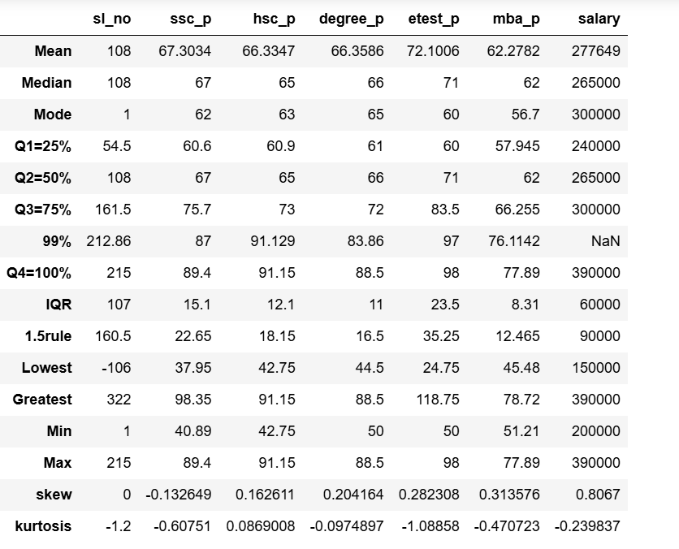

Based on above analysis, SSLC marks in skew range is negative that’s mean value is greater than median and mode. Remaining columns are present under the positive range.

All the columns kurtosis value is fall less than <3. It means platykurtic.